**Rafiq Dandoo**

**Pup Inflation**

In our study we examined if ratings of dog images on twitter were being affected by ratings inflation over time. We examined twitter posts containing dog images from the dates February 2016 through October 2017 to see if there was in fact inflation occurring to these ratings. Our Analysis filtered out ratings above 20 as to eliminate ratings that may not be accurate measurements of how good a dog is and could ruin the overall results.

Our Analysis showed that there is an inflation of dog ratings going on over time and that dog ratings are tending to get higher, at about a rate of 1.83 points increase per year. We can say with above 99% certainty (p < 0.01), that our rate of increase is not 0.

In red we have our Line of best fit which we use to predict what the values are at a certain point of time starting from 2016-02. We can see it is trending upwards with a slope of 1.83/year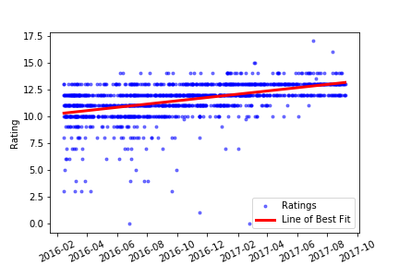

And here is the error of the line showing how far each point actually is from the point the line predicts, as you can see the error is fairly minimal with very few outliers above or below two points of it.